Paulina Pena-Garcia
11/10/2026
ISBA 3330
CODE 7 Airline Delays
For this code assignment, I analyzed flight delay data from 2018 to better understand what factors are related to late arrivals. I started by looking at the overall dataset and comparing airlines to identify patterns in their delays. Based on the results, I decided to focus on American Airlines since it had the most delayed flight records. Then, I used descriptive statistics and linear regression to examine how different variables, such as departure delays and flight distance relate to arrival delays.
The dataset contains 280,295 flight records and 25 variables, including airline information, departure and arrival times, flight distances, and delay measurements. No missing values were found. Across the dataset, the average arrival delay was 63.61 minutes, with a median of 40 minutes and a standard deviation of 76 minutes. Delays ranged from 15 to 2,692 minutes. Since the dataset only includes flights delayed by at least 15 minutes, the findings represent delayed flights rather than overall airline performance.
Descriptive Analysis
American Airlines had the highest number of delayed flights in the dataset, with 56,433 delayed flights and an average arrival delay of 59.98 minutes. Delta Airlines followed with 44,566 delayed flights, while United Airlines had 33,679. American Airlines was selected because its larger sample provided enough observations to examine delay patterns and develop a regression model.
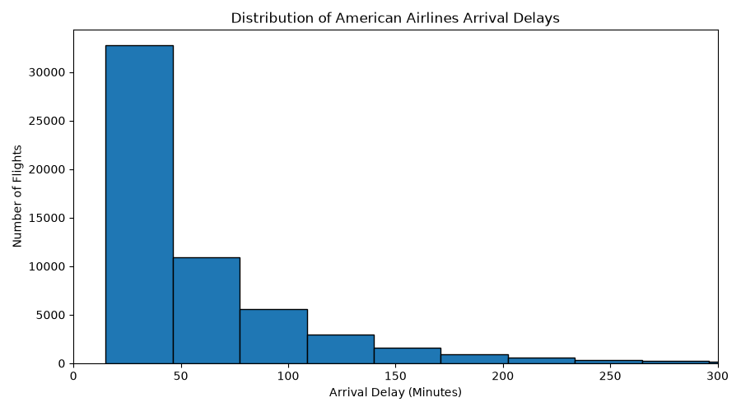
The graph shows that shorter delays were more common, while fewer flights experienced longer delays. This resulted in a right-skewed distribution. American Airlines had a median arrival delay of 39 minutes, compared with an average of approximately 60 minutes, suggesting that unusually long delays increased the overall average.
Correlation Analysis and Predictor Selection
Four variables were examined as potential predictors: departure delay, taxi-out time, flight distance, and scheduled flight duration. Departure delay had the strongest correlation with arrival delay at 0.9494, indicating a strong positive relationship. The other variables had much weaker correlations: taxi-out time (0.0631), flight distance (-0.0088), and scheduled flight duration (-0.0042). All four were included in the regression model to evaluate their relationships when considered together.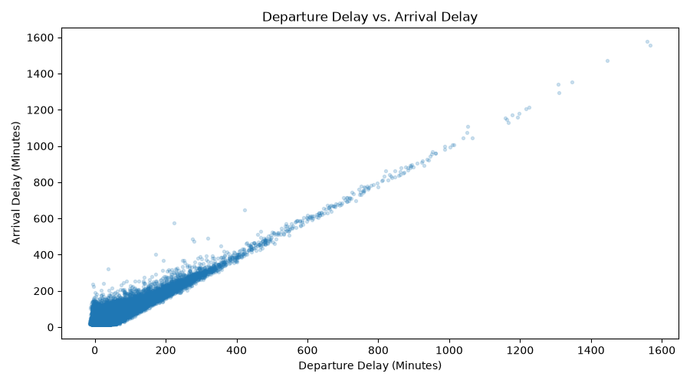
The scatterplot shows a clear upward pattern, indicating that flights departing later generally arrived later as well. This supports the correlation results and suggests that departure delay is an important predictor of arrival delays.
Predictive Analysis
An ordinary least squares (OLS) regression model was created using Python’s statsmodels.api library and 56,433 American Airlines flight records. Arrival delay (ARR_DELAY) was the dependent variable, while the four previously selected variables were used as predictors. The model produced an R-squared values of 0.951, meaning it explained approximately 95.1% of the variation in arrival delays within the analyzed dataset.

Predictor | Coefficient | P-Value
Intercept | -3.8318 | <0.001
Departure Delay | 0.9431 | <0.001
Taxi-Out Time | 0.9290 | <0.001
Flight Distance | 0.0321 | <0.001
Scheduled Flight Duration | -0.2472 | <0.001

All four predictors were statistically significant, with p-values below 0.05. Departure delay had a coefficient of 0.9431, meaning that each additional minute of departure delay was associated with approximately 0.94 additional minutes of arrival delay, holding the other variables constant. Taxi-out time also showed a positive relationship, while scheduled flight duration had a negative coefficient.
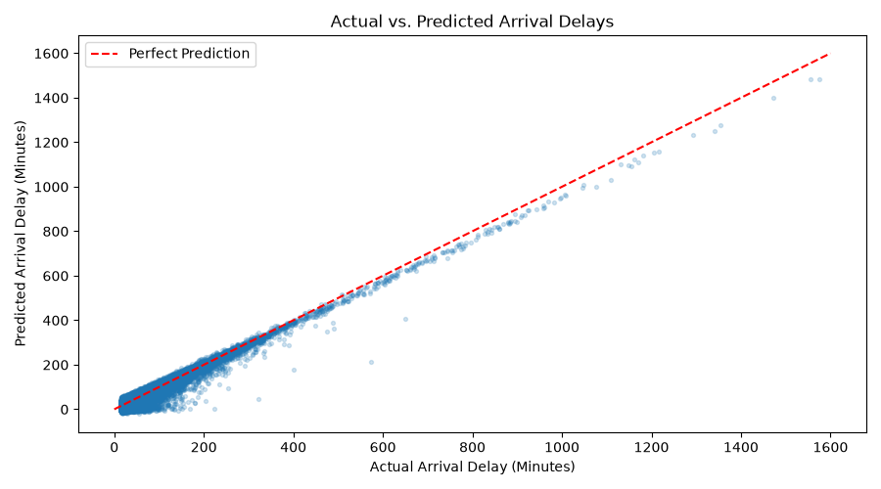
The graph compares actual arrival delays with the model’s predicted values. Most points fall close to the perfect prediction line, suggesting that the model fits the observed data relatively well. These findings indicate that departure delay and taxi-out time can be useful for estimating arrival delays once departure information is available. However, the model was evaluated using the same data on which it was trained, so its accuracy on future flights remains uncertain.
Conclusion
The analysis identified several patterns in American Airlines flight delays during 2018. Shorter delays were more common, and departure delay showed the strongest individual relationship with arrival delay. The regression model explained approximately 95.1% of the variation in arrival delays, with all four predictors statistically significant. These findings show how descriptive statistics and regression analysis can help explain flight delays and estimate arrival times.

